
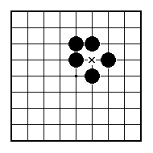
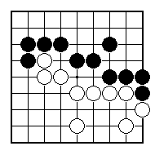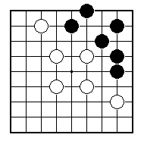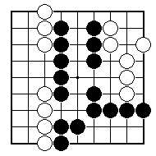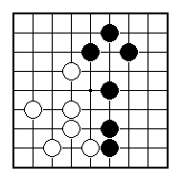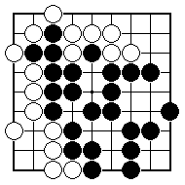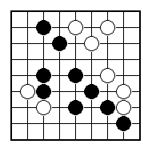
Black to play and reduce White's territory.

Suggest a place for Black to play.

Whereabouts should Black play?

In what area should Black play next?

Whereabouts should Black play?

Suggest a place for White to play.

NAME:
BRITISH GO ASSOCIATION CERTIFICATE LEVEL 3 - SHEET 7

STEALING TERRITORY

